**Leader Overview**



**Volume Overview**

**What does the Bible say about the future?**

*It’s easy to see that our society is obsessed with the future. But what does the Bible say about the future? While it was written thousands of years ago and much of its contents has already taken place, we do get a glimpse of the future in the Bible. We know there is life beyond this life. We know the brokenness and pain in this world will not last forever. We know God will make all things new, and He will right every wrong. For Christians, the future is something we can look forward to.*

**Session Overview**

**Jesus Is Coming Back**

*Jesus is coming back, but the Bible doesn’t tell us when. How can we be prepared for His coming if we don’t know when He is coming back? Through a parable that Jesus told, kids will learn that they must be faithful to Him and ready for His return at any time.*

**Bible Lesson**

Parable of the Faithful Servant

[Matthew 24:42–51](https://ref.ly/logosref/Bible.Mt24.42-51)

**Faith Fact**

Jesus is coming back.

**Faith Verse**

[1 Corinthians 2:9](https://ref.ly/logosref/Bible.1Co2.9) (NLT)

“No eye has seen, no ear has heard, and no mind has imagined what God has prepared for those who love him.”

**Preparing for the Session**

**Leader Preparation Time: 20–25 Minutes**

|  |
| --- |
| ***You Will Need***  ***Large Group***   * *Bible* * *Worship songs (Song suggestions: “Revelation Song” by Gateway Worship; “Ready or Not” by Hillsong UNITED; “Alive” by Hillsong Young & Free; “Zeal” Lyric Video by The Belonging Co)* * *For groups not using a phone or tablet only, add:*   *• Projector or TV*  *• Laptop*  *•* ***Faith Fact Slide***  *•* ***Faith Verse Video*** *or* ***Slide***  *•* ***Bible Lesson Video***  *•* ***Teaching Point Slides 1–3***   * *Smartphone or watch* * *Calendar* * *Binoculars* * *Portable device (phone/tablet)* * *Video game* * *Picture of a group of friends in a picture frame*   ***Small Group***   * *Bibles for kids in your group to share* * ***Small Group Activity Page****, one per kid* * *Pencils, one per kid* * *Crayons or markers*   *To access session content and videos from a computer, visit:* [*BibleEngagementProject.com/downloads*](https://bibleengagementproject.com/downloads) |
| ***Getting Ready***  ***Large Group***   * *Download videos and slides if needed.* * *Select worship song(s) and have them ready to play.* * *Read the Bible Lesson Scripture to prepare for Teaching Time.*   ***Small Group***   * *Print copies of the* ***Small Group Activity Page****, one per kid.*   *First time leading* Learn *for Kids? Check out the* [*Facilitator Guide*](https://0b769b0ed3569ef9d18b-f88d8272f61086866d50d048b43ef630.ssl.cf2.rackcdn.com/sites/biblengagementproject/Listen_Facilitator_Guide.pdf)*.* |

**Large Group**

**30 Minutes**

*See what’s needed at the beginning of the session.*

**Introduction**

Welcome, everyone! Who wants to know the future? (*Group response)* What’s something you’d like to know about the future? *(Allow responses.)* Today we’ll find out what the Bible says about the future.

God’s Word might not give us every detail we want, but it tells us what we need to know. For example, the Bible tells us Jesus is coming back, but does it say *when* He is coming? *(Group response)* No! The Bible tells us no one knows when Jesus will come back except God the Father. The day and time Jesus will return isn’t as important as what we do while we’re waiting. Let’s find out more about that today.

**Faith Fact**

It’s time for us to find out today’s Faith Fact. Actually, I already gave it away! Our Faith Fact today is **Jesus is coming back**.

• *Show the* ***Faith Fact Slide.***



Who’s excited that Jesus is coming back? *(Group response)* As we say the Faith Fact, let’s point up to heaven when we say, “Jesus,” and down to ourself when we say, “is coming back.” Ready? **Jesus is coming back**. One more time: **Jesus is coming back**. That’s some of the best news ever!

**Game**

**Which Month?**

We don’t know the day or time Jesus is coming back. We don’t even know the month or year! But we can trust that He will return on the best day. None of us knows when Jesus will return, but let’s find out if we know the time of some other events. We’ll start with your birthday. When I say, “Go,” shout out the month of your birthday. Ready? Go! *(Allow responses.)* I’m glad you know that one!

Most holidays happen about the same time every year. I’ll say a holiday and a month it could be in. If I name the right month, stand up. If I’m wrong, stay seated. Let’s play!

*(* indicates the correct response)*

• Christmas—December*

• St. Patrick’s Day—August (March*)

• Independence Day—July*

• Veterans Day—September (November*)

• Memorial Day—May*

• New Year’s Day—June (January*)

• Columbus Day—October*

• Valentine’s Day—April (February*)

• Labor Day—September*

• Thanksgiving—October (November*)

• Presidents’ Day—February*

• Martin Luther King Jr. Day—December (January*)

• Easter—March* or April*

That last one was a little tricky because it can be either one of two right answers. What’s your favorite holiday? Shout it out! *(Group response)* It’s always fun to have holidays to look forward to. But it’s not nearly as important as looking forward to Jesus’ return.

**Worship**

Jesus promised that He will come back one day. I have an idea of something we can do while we wait! We can worship Jesus through singing. Let’s worship Him right now.

• *Lead the kids in singing one or two praise songs. See suggestions at the beginning of the session.*

**Bible Lesson**

Worshipping together is one way we can connect with Jesus while we wait for Him to come back. We can also keep learning more from God’s Word. Pull out your Bible or Bible app and get ready to discover something new about Jesus’ return.

Jesus used lots of parables to teach important truths about God. A parable is a story with a point that’s easy to remember. Jesus told parables about His return, because He wants everyone to be ready when He comes back. We’re about to dive into one of those parables, but first let’s pray.

**Prayer**

|  |
| --- |
| *Dear God, please help us understand what You want us to learn from Your Word today. Amen.* |

**Video Intro**

Before we look at the Bible story, let’s watch this video.

• *Play* ***Bible Lesson Video.***

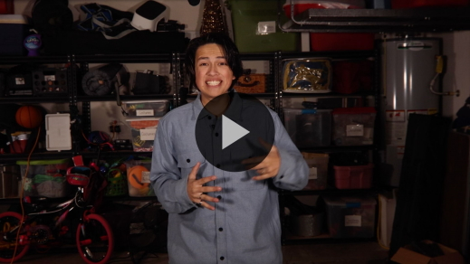

**Bible Story**

**Parable of the Faithful Servant**

That video really made me want to find out more about our Bible story! Most of us are curious about the future. Do you ever wonder what it will be like when Jesus comes back? *(Group response)* The people in the Bible were just like us. Even the disciples wanted Jesus to tell them about the future and when certain things would happen.

Jesus didn’t give the disciples the exact answers they were looking for. Instead, He told them a parable. Jesus didn’t tell this story just for the fun of it. He told it to teach the disciples about His return and what they should be doing until then. It’s time to open up your Bible or Bible app and go to [Matthew 24:42–51](https://ref.ly/logosref/Bible.Mt24.42-51).

• *Read the passage aloud to the group.*

• *In order to keep Large Group time moving along, we don’t recommend having the kids read.*

• *Optional: Remind the kids to mark this place with their Bible Bookmark, so they can read it on their own at home.*

**Teaching Time**

|  |
| --- |
| ***You Will Need***   * *Bible* * *Smartphone or watch* * *Calendar* * *Binoculars* * *Portable device (phone/tablet)* * *Video game* * *Picture of a group of friends in a picture frame*   *No prep needed for this activity.* |

In this parable, Jesus talked about a master who left his servant in charge. A master is like a boss, and a servant is like a worker. Remember, a parable is a story with a special meaning that teaches us something. Usually, people in a parable represent, or stand for, someone else. Who do you think the servant represents in this story? *(Allow responses.)* The servant is you, me, or anyone else who is following Jesus.

It’s really important to understand that Jesus is coming back for only His followers. There’s just one way to go with Jesus when He returns—by making the decision to follow Him *before* He comes back, to choose to become a Christian. We’ll talk more about that later, but for now let’s go back to Jesus’ parable.

Who do you think the master represents in the parable? *(Allow responses.)* Yes, the master is Jesus, who has left us with a job to do. After we believe in and start following Jesus, our job is to live for Him and tell others about Him. Jesus wants us to use our time well as we wait for Him to come back.

Remember our Faith Fact? **Jesus is coming back.** Say it with me. **Jesus is coming back.** When we remember that, we’ll keep making good choices no matter how long we have to wait for His return. Here are a few things we can learn from Jesus’ parable and apply to our life.

**1. Only God the Father knows when Jesus will return.**

• *Show the* ***Teaching Point 1 Slide.***

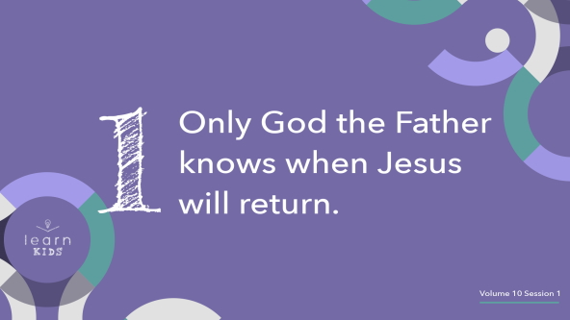

We know Jesus is coming back for His people. *(Begin flipping through the pages of your Bible.)* When He will come is such an important detail that it’s hard to believe it’s not in our Bible somewhere. But it’s not in there. I’ve checked and so have lots of people who know more about the Bible than I do. Why do you think God left that detail out of the Bible? *(Allow responses.)*

Some people have tried to figure out exactly when Jesus will return, but they’re wasting their time. The Bible doesn’t give us the day *(hold up calendar)* or the time *(point to smartphone or watch)* it will happen. In fact, the Bible tells us no one knows the day or time Jesus will return—not even the angels! We shouldn’t waste our time and energy trying to figure out exactly when Jesus is coming back because we can’t possibly know. Instead, knowing Jesus could come back at any moment should remind us to use our time wisely and be ready for His return.

**2. Keep watch for Jesus to return.**

• *Show the* ***Teaching Point 2 Slide.***

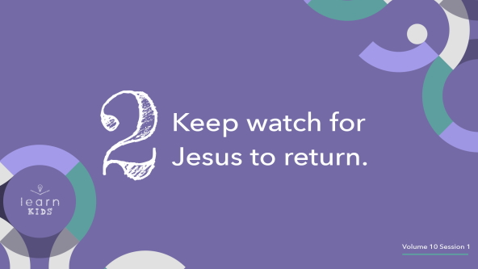

Because we know Jesus is coming back, we should be ready and watching for Him. *(Hold up binoculars and look through them while you continue to talk.)* Does that mean we should buy an expensive pair of binoculars and spend all our free time staring up at the sky? *(Group response)* No! That would be pretty silly and a big waste of time.

Then what does it mean to watch for Jesus to return? It means we shouldn’t be caught off guard when Jesus comes back. We should be prepared all the time. We don’t know whether Jesus will return tomorrow or in five hundred years. We should expect Him to come back at any moment.

First, we should make sure we believe in and follow Jesus. After that, we should let Jesus be in charge of the words we say, the things we do, and how we spend our time. If Jesus came back today, would you be ready for Him?

**3. Stay faithful until Jesus returns.**

• *Show the* ***Teaching Point 3 Slide.***

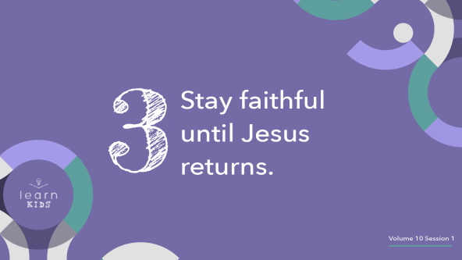

We don’t know when Jesus is coming back, so we must stay faithful to Him while we wait. What does it mean to stay faithful to Jesus? (*Allow responses.)* Those are some great answers. To be faithful to Jesus, first we need to have faith in Jesus, or believe Jesus is God’s Son. That’s why trusting in Jesus for salvation is the first and most important way we get ready for His return. Salvation is asking Jesus to forgive our sins, the things we do that we know are wrong. Remember, it’s the only way we can go with Jesus when He comes back.

Then after we believe in and become followers of Jesus, we stay faithful to Him by sticking to His plan for our life. We live by what the Bible says. We obey our parents. We spend time with Jesus every single day. Jesus’ parable shows us that if we live this way, we will be rewarded when He comes back.

It’s so easy to get distracted by things and even people. When that happens, we might lose focus on the fact that Jesus is coming back. What are some ways you can be distracted by things or people? *(Allow responses.)*

You already guessed some of the main distractions I was thinking of. We can all agree we probably spend way too much time on devices *(hold up the portable device)*, playing video games *(hold up the video game)*, and maybe even hanging out with friends who don’t help us get closer to Jesus *(hold up the picture frame)*.

We should spend time each day with Jesus and other people who believe in and are following Jesus. If we spend more time being distracted than spending time with Jesus, it’s hard to remain faithful until He returns.

**Prayer and Response**

*Consider playing a worship song softly in the background while kids pray.*

Do you want to be ready to go with Jesus when He comes back? Remember, He is not coming back for everyone but only the people who believe in and follow Him. If you’ve never made this decision by asking Jesus to forgive your sins, then today can be the day. If you already believe in and follow Jesus, then you have a special job to do, just like the servant in Jesus’ parable.

Let’s talk to Jesus. Let’s pray and ask Him what He wants each of us to do.

|  |
| --- |
| Dear Jesus, I open my heart and mind to You. Please show me how I can get ready for You to come back. |

• *Allow some time for kids to pray on their own.*

Now if you want to believe in and start following Jesus or if you want Jesus’ help to stay faithful to Him until He comes back, I invite you to pray with a leader.

• *Take time to pray with kids individually as needed.*

**Prayer**

• *Optional: Have the kids repeat phrases of the prayer after you.*

|  |
| --- |
| Dear Jesus, I’m so thankful You are coming back. Help me to be ready by choosing to follow You. Then help me stay faithful and live every day like it could be the day You return. Amen. |

**Faith Verse**

Our Faith Verse is a great reminder that we can’t possibly know when Jesus will return. All we know is we need to be ready, and it will be awesome. Let’s say our Faith Verse and do the actions together.

• *Play* ***Faith Verse Video.***

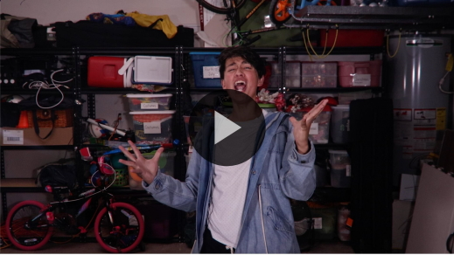

[1 Corinthians 2:9](https://ref.ly/logosref/Bible.1Co2.9) (NLT)

“No eye has seen, no ear has heard, and no mind has imagined what God has prepared for those who love him.”

I hope we get to see Jesus come back while we are still alive. Wouldn’t that be amazing? *(Group response)*

**Faith Fact**

Before we go to our small groups, let’s take a look at our Faith Fact again.

• *Show the* ***Faith Fact Slide****.*



Say it with me. **Jesus is coming back.** Thanks for joining me as we learned from God’s Word today! I can’t wait to find out more about what the Bible says about the future.

• *Dismiss kids to Small Group time or to go home if your group time ends here.*

**Small Group**

**30 Minutes**

*This section can be done in conjunction with the large group or on its own if you do small groups with your kids. During Small Group time, the goal is to connect the kids with the Word of God and to each other. All activities are led by the small group leader.*

**Group Connection**

**Who Knows When?**

Only God the Father knows when Jesus is coming back. It’s up to us to stay faithful and ready for Jesus to come back anytime. In this game, you won’t know when it’s your turn to get up and claim your spot, so you have to stay ready. Here’s how we’ll play.

• *Have kids sit in a circle.*

One person will be It and walk around the circle. The one who’s It will tap each person lightly on the shoulder as they go around. Then the one who’s It will say, “It’s time!”

If you’re the person who was chosen, you’ll jump up and chase the one who’s It around the circle. If you tag them before they make it to your spot, they’re It again. If not, you’re It for the next round. Who’s ready to play? *(Group response)*

• *Keep playing until most of the kids have been It or until you run out of time.*

Some of you were really quick to react. You were ready to go! Let’s do our best to have that same focus on Jesus so we can be ready for His return, too.

**Learn about It**

|  |
| --- |
| ***You Will Need***   * *Bibles for kids in your group to share*   *No prep needed for this activity.* |

**Scripture Search:** [2 Peter 3:8–13](https://ref.ly/logosref/Bible.2Pe3.8-13); [Matthew 24:35–44](https://ref.ly/logosref/Bible.Mt24.35-44); [1 Thessalonians 4:13–18](https://ref.ly/logosref/Bible.1Th4.13-18); [1 Corinthians 15:50–58](https://ref.ly/logosref/Bible.1Co15.50-58)

Let’s learn more about what God’s Word says about Jesus’ return. As we read these verses, let’s ask ourself this question: What does this Scripture mean for our life today and the future?

• *Give each kid a Bible and search for one or more of the Scriptures as a group together (as time allows). When everyone has found the Scripture, have one of the kids read it. Then answer the question about it: What does this Scripture mean for our life today and the future?*

• *Pair kids who need additional help with older kids or start simple and look up the session’s Bible story Scripture:* [*Matthew 24:42–51*](https://ref.ly/logosref/Bible.Mt24.42-51)*. Kids will get better at finding Scriptures the more they practice.*

• *Optional: Make this a competition to see who can find the Scripture first.*

**Bible Reading Tip**

Reading the Bible is a great way to spend time with God every day. After all, it’s called *God’s* Word for a reason! The Bible is literally words to us from God. People wrote down His words and passed them down for thousands of years. The Bible is one of the oldest and most popular books for a reason. When you spend time reading your Bible, don’t stay in just one section. Try reading a little of the Old Testament and the New Testament each time. Reading from both sections will help you better understand who God really is.

**Challenge**

I want to challenge you to read one chapter from the Old Testament and one chapter from the New Testament every day this week. If you don’t know how to read that much of the Bible on your own yet, ask your parents or someone in your family to help you. You can even challenge your family or friends to join you!

**Faith Fact**

As you read God’s Word, watch for verses about Jesus’ return. Who can tell me the Faith Fact? *(Allow responses.)* Let’s say it together one more time. **Jesus is coming back.**

**Group Discussion**

*Feel free to use all or just a few questions as a jumping-off place for good discussion. Questions marked with * are designed for more conversation. Adjust the questions based on the age or maturity of your group. Typically, older kids will be able to dive a little deeper than younger ones.*

**Questions**

• *If small group activities are not immediately following large group time, you may want to read the Bible story passage before this discussion.*

What did Jesus say would happen if the master returned and found that the servant had done a good job?

How did the Bible say the master would return?

* Do you think Jesus will come back in your lifetime? Why or why not?

Why do you think the Bible doesn’t tell us when Jesus will return?

* What does the word *faithful* mean to you?

How can you spend your time wisely as you wait for Jesus to come back?

* If you want to focus more on Jesus, what is something else you could spend less time doing?

What is one way you like to spend time with Jesus?

Are you looking forward to Jesus coming back? Why or why not?

**Prayer Requests**

*Finish group discussion by sharing prayer requests and praise reports. Keep track of your small group’s prayer requests and review them each time you meet.*

**Prayer**

*Have kids pray for each other’s prayer requests.*

**Faith Verse Review**

Our Faith Verse is [1 Corinthians 2:9](https://ref.ly/logosref/Bible.1Co2.9). Isn’t it incredible that God’s plans for us are so amazing that we can’t even imagine them? That’s what our Faith Verse tells us. Let’s say it together before we play a game.

• *Show* ***Faith Verse Video.***



[1 Corinthians 2:9](https://ref.ly/logosref/Bible.1Co2.9) (NLT)

“No eye has seen, no ear has heard, and no mind has imagined what God has prepared for those who love him.”

**Faith Verse Fun**

**Eyes, Ears, and Minds**

Let’s see how quick your reflexes are. I will say “eye,” “ear,” or “mind,” and you will have to quickly point at that body part. If you point to the wrong body part or aren’t fast enough, you’ll be out. Stand up and let’s play!

• *Go over the Faith Verse quickly several times, pointing at the different body parts.*

• *Challenge Round: As you say the words, point to the wrong body parts.*

• *Optional: Add more actions like pointing up for “God” and covering your heart for “love.”*

That was a lot of fun! Let’s say the verse together one more time.

• *Repeat the Faith Verse.*

That’s an awesome promise to think about!

**Activity Page**

**Prayer Plan**

|  |
| --- |
| ***You Will Need***   * ***Small Group Activity Page****, one per kid* * *Pencils, one per kid* * *Crayons or markers*   ***Getting Ready***   * *Print copies of the* ***Small Group Activity Page****, one per kid.* |

We don’t know when Jesus is coming back, but we can use our time wisely and spend time with Him while we wait.

• *Give each kid a copy of the* ***Small Group Activity Page*** *and a pencil.*

This page shows four things you do almost every day. In the space under each picture, write something or someone you can pray for every time you do this activity. Use your page as a prayer guide to remind you to pray this week.

• *Ask the kids to share what they are writing as they complete the activity.*

**Dismissal**

Ready or not, Jesus is coming back! It might be tomorrow or it could be in a thousand years. I don’t know about you, but I want to be ready whenever He returns. Let’s close in prayer.

**Prayer**

|  |
| --- |
| *Dear Jesus, please help us keep our focus on You and remove things from our life that distract us from serving You. Prepare our heart and mind for Your return. Amen.* |

**Faith Fact Recap**

• *Show the* ***Faith Fact Slide****.*



We can’t leave today without reviewing the Faith Fact one more time! Are you ready? (*Group response)* Say it with me. **Jesus is coming back.** One more time as loud as you can. **Jesus is coming back.** Remember to keep your focus on Jesus and spend time with Him every day this week. See you next time!

• *Send home the* ***Small Group Activity Page****.*

• *Remind parents that there are* ***Family Devotions*** *available on the app to do with their kid.*

• *Tell everyone the date and time for the next session.*